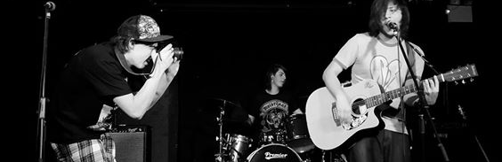

MEDIA PRODUCTION SUMMER TASK
We are really pleased that you have chosen to take a media course with us at DV8sussex. Over the summer break we would like you to do a couple of small tasks, that you will bring into your first lesson. This will give us an idea of the kind of work you can do and what kind of media you like.

Task 1
Make a short film titled “The Journey”. The film only needs to be between a minute to two minutes long. It can be a record of a journey you do every day, like walking the dog or it can be about a holiday you have been on. If you want you could make a fictional film with the title Journey. You can make the film on your phone or a stills camera with a movie mode or if you have a camcorder. If you would rather you could take a set of still images to tell the story of your journey and present them as a set of prints or a slide show. Your film should attempt to include examples of the following:
Close-ups, wide-shots, mid-shots; A panning shot; A tilting shot; A tracking shot; A series of cutaways

Task 2
Write a review of a film you have seen. Read some other film reviews and see what kind of information and style they include, the different writing styles there are. In your film review explore as many of the following as you can:
Narrative structure ; Cast & Crew ; Genre ; Mise en scène ; Audio-Visual style ; Editing ; SFX & VFX ; Production process ; Distribuition & Advertising.

There are some links below to videos on how to make films on your phone, where to find free editing software and samples of films people have made on phones.

We are looking forward to see your work in September and an exciting year with you at DV8sussex

Regards, The DV8 media team

USEFUL LINKS
How to make a film on your phone
https://www.youtube.com/watch?v=oljt8IU0Npk
http://videoandfilmmaker.com/wp/index.php/tutorials/smartphone-filmmaking-tips/
Editing software
http://www.techadvisor.co.uk/test-centre/photo-video/best-free-video-editing-software-2017-3614829/
http://www.techadvisor.co.uk/test-centre/photo-video/best-free-video-editing-software-2017-3614829/
https://www.youtube.com/watch?v=snbTKrLTDhQ
https://www.youtube.com/watch?v=DSSdlP6OC-Y
Film shoot on phones
https://www.digitaltrends.com/photography/movies-and-tv-shows-filmed-with-an-iphone/
https://www.wired.com/2014/07/smartphone-movies/
Film review websites
https://www.raindance.org/top-10-film-review-websites/
http://www.adweek.com/digital/top-movie-review-and-rating-sites/

