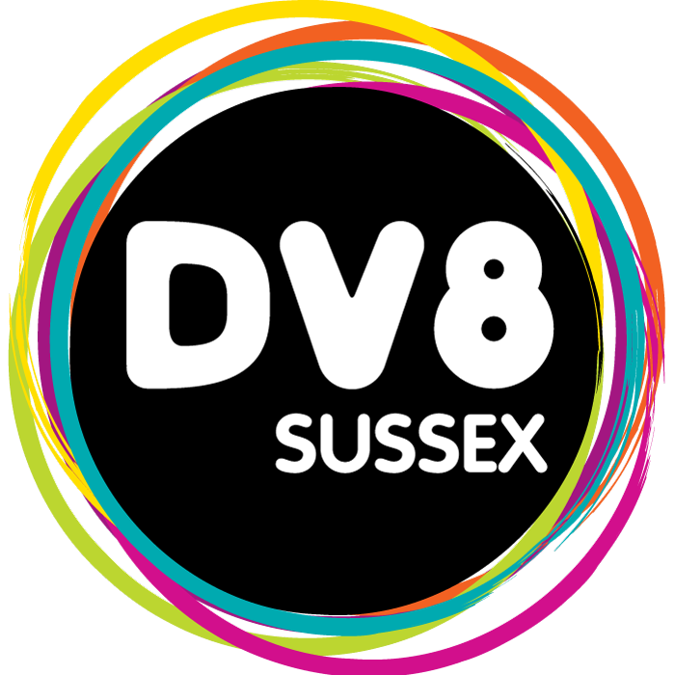


INTRODUCTION TO MUSIC, MEDIA & DIGITAL SUMMER TASK
We are really pleased that you have chosen to join our Introduction to Music, Media & Digital course in September. To help get your ready for the start of term we wanted to set a couple of small tasks for you to complete over the summer.

Task 1

As our Introduction to Music, Media & Digital course is all about being creative we want you to make one thing over the summer that shows your creativity. It could be lyrics to a song, a photo you’ve taken, a story, a drawing etc. anything that used your creativity. Bring this along with you on your first day to help the tutors get a better sense of who you are and what you like.

Task 2

To go alongside something that you’ve made we want you to find something creative that inspires you. It could be your favourite song, a YouTube video, a video game etc. anything that always makes you feel inspired and creative. Write down a few sentences about why you have chosen this song/video/game etc. in particular and be prepared to talk about it when you join the class.

We hope you have a great summer and we are looking forward to welcoming you to the Introduction to Music, Media & Digital team in September.

Best wishes

Dv8 Sussex

