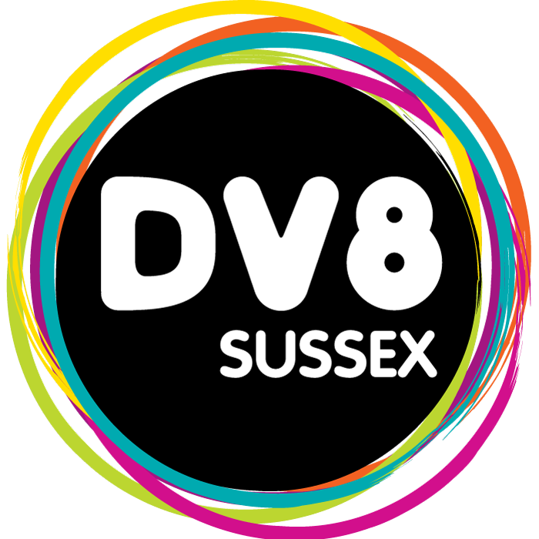

EVENT MANAGEMENT SUMMER TASK
We are really pleased that you have chosen to join our Event Management course in September. To help get your ready for the start of term we wanted to set a small task for you to complete over the summer.

We would like to find out a bit more about how you like your events. We hope you have some recreational events lined up between now and when we start in September.

We would like you to tell us about one event of your choice that you go to: it could be a gig, a sports event, or a festival, or a fete, or a lecture, or a rally, or a play. Anything that you are interested in.

Please can you write a short account of the event: tell us when it was and where it was, and what you thought was good about it (or not, if it turns out to be duff). Also, we would like you to bring an image from it: this could be a photo, or a poster or flyer: collect something visual to tell us about.

The written bit should be about 300 - 500 words as a guide. Have it ready for the first Friday back next term: Friday 22 September 2017.

Have fun!
We hope you have a great summer and we are looking forward to welcoming you to the Events Management team in September.

Best wishes

Sam, Rich & James

