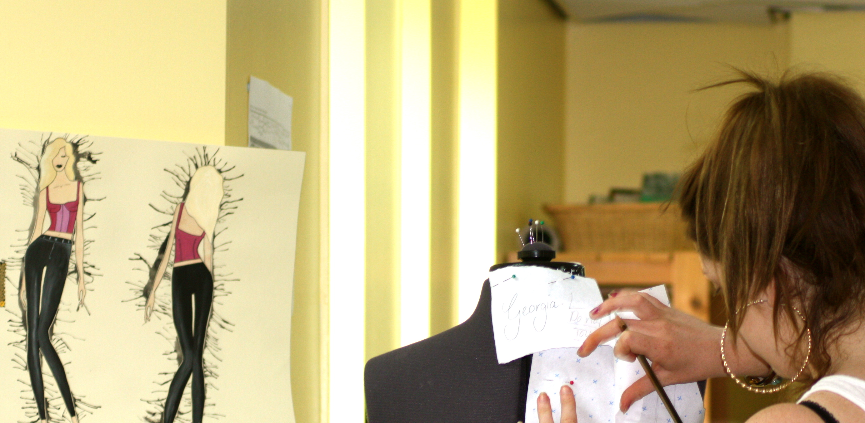
Fashion & Design Task

- To compile a sketchbook filled with magazine photos and fabric/ wallpaper/ paper/ colour swatches of Spring, Summer, Autumn and Winter colours. For example –‘Ice cream spring colours’, ‘Summer Brights’, ‘Autumnal gold tone leaves’, ‘Autumn tweeds’ ‘Frosty Winter shades’, ‘Winter berry jewel tones’, or any other titles that they can think of relating to this project. This will heighten awareness of colour trends, imagery, textures and shapes, and will help with future research, as well as being good to show at interview for next college.
- To research a fashion designer from any period or country in the last 150 years, and write 500 words on them. This must include pictures to illustrate, and be in your own words, not copied and pasted. It can be written by hand, with your own illustrations, or using Word with photos, or a combination of both. Please include where you have taken your information from – e.g website and date accessed, or book title, author and date published. This can be put in your sketchbook.

We hope you have a great summer and look forward to seeing you in September.
Sharon Oliver
Fashion & Design Tutor

