WORKSHOPS / TALKS
10am – 11am // Komedia Studio
Sarah Perryman: Participation & Development Manager, Brighton Fringe
Come up with an idea for a Fringe event - working through where, when, how, who etc.
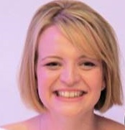
Sarah joined Brighton Fringe in November 2013 as Arts Industry Coordinator and took on her current role in June 2014. She has a first class BA in Arts Management and Theatre Studies (London Met) and an MA in Creative Producing for Theatre & Live Performance (Birkbeck). Sarah has worked in the arts for 18 years, and was a freelance theatre producer for 10 years, producing work at both Brighton and Edinburgh Fringe Festivals. ______________________________________________________________________________________
11.15am – 12.15pm // Komedia Studio
John Young: News Reporter / Presenter
Hear clips from the camera operator, producer, graphic designer and many others, offering advice on how they got their jobs.
I’ve been a television and radio journalist for 26 years, almost all of it with the BBC. My focus on air has been regional television news across the UK, but I’ve also enjoyed spells as a national news reporter and regional documentary maker. I’ve specialised in reporting about educational issues — picking up one or two awards for my work along the way. I continue to report and read the news in the south-east of England. ______________________________________________________________________________________
1.30pm – 2.30pm // Komedia Studio
Tim Mapleston: Designer
Explore the world of marketing and branding, learning how it can improve and promote your ideas.
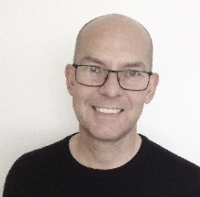
An experienced and creative graphic designer Tim has worked for several agencies and organisations, responsible for designing a wide variety of marketing material including: logos, branding, icons and infographics, brochures and other literature. He has also designed several magazines and books - on subjects such as food, travel, lifestyle, interiors and business. I have also art directed successful pitches for several clients.
______________________________________________________________________________________
1.30pm – 2.30pm // Komedia Main Space
Tom Hines: Project Manager, Audio Active
Ableton push down – production / rap workshop
Tom has been delivering rap workshops for AudioActive for over a decade and knows the organisation and its artists very well. Alongside this he has a background in therapeutic care and has been teaching art in EBD schools. Tom also has 20 years of musical experience and is in charge of Slip Jam, the hip hop open mic event, which has been running for over 15 years.

2.30pm – 3.30pm // Komedia Studio
Louise O’Mahony: Fashion Designer
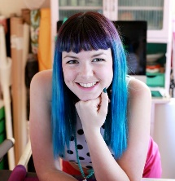
Louise O’Mahony is a Brighton based designer whose designs focus on embracing the femininity of the female silhouette, and she strongly believes what a person chooses to wear should reflect their characteristics and personality. Her designs are not for the wallflowers, bold shapes and bright shades are trademarks to her designs. She also designs and manages 1950’s inspired ready to wear label, Oh My Honey.
______________________________________________________________________________________
IMAGES PANEL
10am – 11am // Komedia Main Space
Victoria Melody: Performance Artist
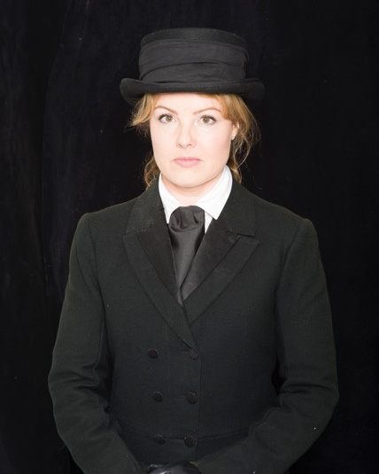
Victoria Melody is an award winning British artist with a background in fine art. She makes one-woman theatrical shows, performance interventions and films mainly about Britain’s pastimes, passions and tribes. Fascinated by anthropology, she immerses herself into communities and becomes an active participant in their rituals as research for her work. In the past she has become a pigeon racer, a northern soul dancer, a championship dog handler and a beauty queen. She is currently training to become a funeral director. Victoria has presented her work nationally and internationally at venues including Soho Theatre, Bristol Old Vic, Battersea Arts Centre, Summerhall (Edinburgh Festival Fringe), Cherry Lane Theatre (New York), Virginia Art Festival, Push Festival (Canada), Aarhus Festival (Denmark) and Brisbane Festival (Australia).
______________________________________________________________________________________
Dan Skelt: Filmmaker
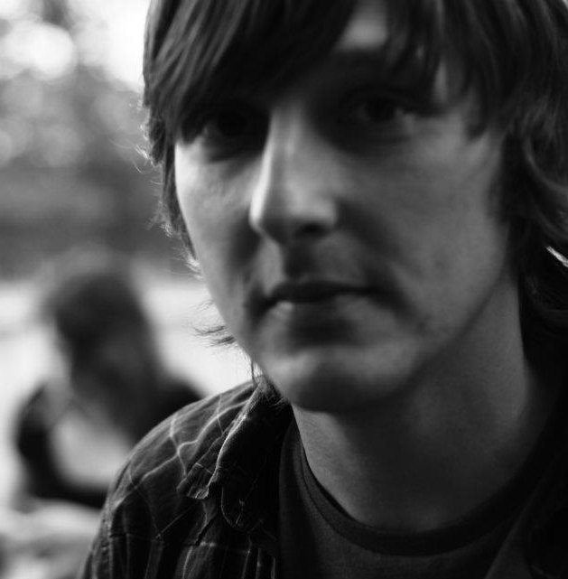
For the last four years I have been working mainly as a freelance videographer doing web content videos, internal training videos and weddings as well as working on short films, features, music videos and documentaries. A lot of the work has been with such companies as Legal & General, The National Trust, CLASP, Anatomic & Co, DH Ready Branding, Brighton Latest TV, Littlehampton Musical Comedy Society and others. As well as the visual work, I also work on the Two Bit Productions fictional podcast series Whispers Through The Static as co-producer and writer of some of the episodes.
______________________________________________________________________________________
Liv Butler-Stroud: 3D Environment Artist, Creative Assembly
My name is Liv Butler-Stroud and I’m a 3D Environment Artist at Creative Assembly. In 2012 I completed an Art and Design foundation at the City of Bath College. I then went on to do a BA Hons in 3D Games Art at the University of Hertfordshire. Now I work at an Environment Artist and we have recently released the game, Halo Wars 2.

______________________________________________________________________________________

SOUND PANEL
11.15am – 12.15pm // Komedia Main Space
Leon Holder: Head Engineer, The Hope & Ruin / Bleach
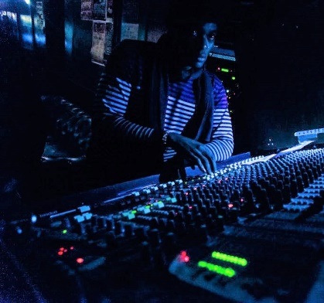
I have been working in the music and audio industry for little under 10 years. Music and audio are my passion. After attaining my degree, I began working in venues almost immediately. I currently hold the role of head engineer in two separate venues in Brighton - The Hope and Ruin & Bleach. Over the past 10 years I have also worked as tour engineer / tour manager and monitor engineer. My work in the industry has and often takes me abroad. I have built up a vast network of links and contacts in many aspects of the industry such as event promoters, music labels, PA and audio equipment hire to name a few.
______________________________________________________________________________________
Tim Ansell: Games Sound Designer, BottledBy
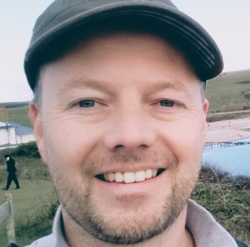
Tim Ansell has recently co-founded BottledBy Games, a new studio looking to continue the heritage of Brighton's game development community. He is able to offer advice in many areas of interactive audio and sound design based on 11 years as the in-house audio expert at Relentless Software.

______________________________________________________________________________________
Lee Morrison: Brighton Music Conference / AFEM (Association of electronic Music) Executive board member
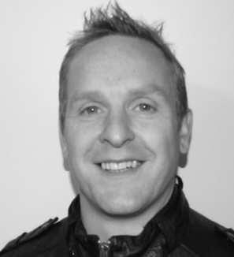
With over 20 years of music industry experience, Lee has a wealth of knowledge in distribution, label management and licensing. By starting to work in the digital music space very early in its inception, Lee has seen the births of key services like iTunes, YouTube, Beatport, Spotify and Juno and more recently has worked heavily on the collection of performance related income for record labels. More recently Lee has been working with the Brighton Music Conference and is in charge of planning and scheduling the pro speakers and panels for this year’s event.
______________________________________________________________________________________
Rob Flinn: Electronic Engineer / Technician
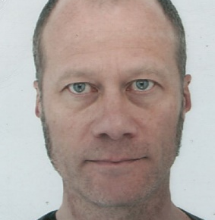
I am an electronics engineer & work as a freelance studio technician. A lot of what I do is general studio maintenance. But I also restore vintage equipment for people, provide wiring solutions & plans for studios, DO modifications & make custom equipment for people. I also sometimes get involved in digital installs, mainly in the film industry. I have a background as a Musician, live sound engineer and a studio owner.
______________________________________________________________________________________
WORDS PANEL
2.30pm – 3.30pm // Komedia Main Space
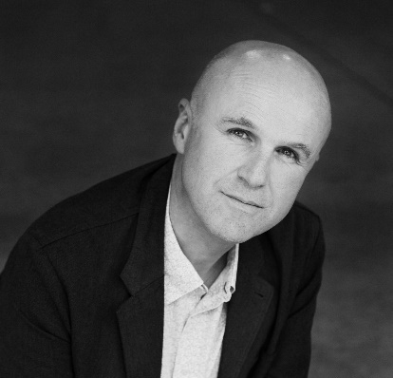
Tim Crouch: Writer / Director / Performer
Tim was an actor for many years before starting to write – and he still performs in much of his work. His plays include My Arm, ENGLAND (a play for galleries), the OBIE award winning An Oak Tree, The Author, Adler & Gibb and (with Andy Smith) what happens to the hope at the end of the evening. Tim tours his work nationally and internationally. For the RSC Tim has directed The Taming of the Shrew, King Lear and I, Cinna (the poet) – all for young audiences. Other directing credits include Jeramee, Hartleby and Oooglemore for the Unicorn Theatre and The Complete Deaths for Spymonkey. Tim is published by Oberon Books.
______________________________________________________________________________________
Lucy Morrison: Associate Director, Royal Court Theatre
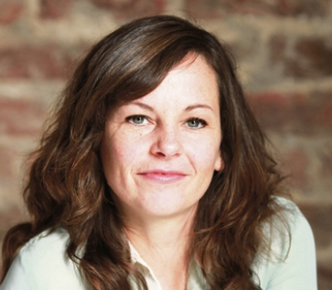
Lucy Morrison is Associate Director at the Royal Court where her credits include Plaques and Tangles by Nicola Wilson, Pests by Vivienne Franzmann (Royal Court and national tour) and Product by Mark Ravenhill (Traverse Theatre and European tour). Pests was a Royal Court co-production with Clean Break for whom Lucy worked as Head of Artistic Programme and while with the company, directed Billy the Girl by Katie Hims (Soho Theatre & National prison tour), Little on the Inside by Alice Birch (Almeida Festival and Latitude), it felt empty when the heart went at first but it is alright now by Lucy Kirkwood (Arcola Theatre) and This Wide Night by Chloe Moss (Soho and national tour). ______________________________________________________________________________________
Paul Hodson: Writer / Director, The Future is Unwritten
Paul Hodson has written and directed for the theatre for over 30 years. For seven years he worked in TV, writing over 100 hours of broadcast drama. He was Director of Brighton Theatre Events for over a decade, commissioning and writing new plays for national touring, and currently runs The Future is Unwritten, who have just toured his play Still, about privacy. His play Meeting Joe Strummer won an Edinburgh Fringe First and his adaptation of Nick Hornby’s Fever Pitch played in the West End and toured for six years. He has three film scripts ‘in development’.
______________________________________________________________________________________
We would like to say a massive thank you to all the guest speakers / people running workshops for giving up their time today and taking part in our Creative Careers Day.

